## Using CSS in SharePoint 2013

**Lab Time**: 45 minutes

**Lab Folder**: C:\Student\Modules\SharePointBrandingAssets\Lab

**Lab Overview**: In this lab you will get hands-on experience working with CSS inside SharePoint.

### Exercise 1: Styling a Layout Using CSS

In this exercise you will use CSS styles to make the paragraphs at the bottom of the page display in 2 columns on the Welcome page.

1. **Open** [http://www.wingtip.com/](http://www.wingtip.com/Pages/about.aspx) **in your web browser. You will see at the bottom of the page the paragraph with the heading, “Real Men prefer Remote Control (RC)” and “Reality is for People That Can’t Handle Toys” are stacked and displaying in one column. The first heading and paragraph is located in its own <div>, as is the second. Each <div> has a unique class that has been applied that will be used to move and style the divs.**

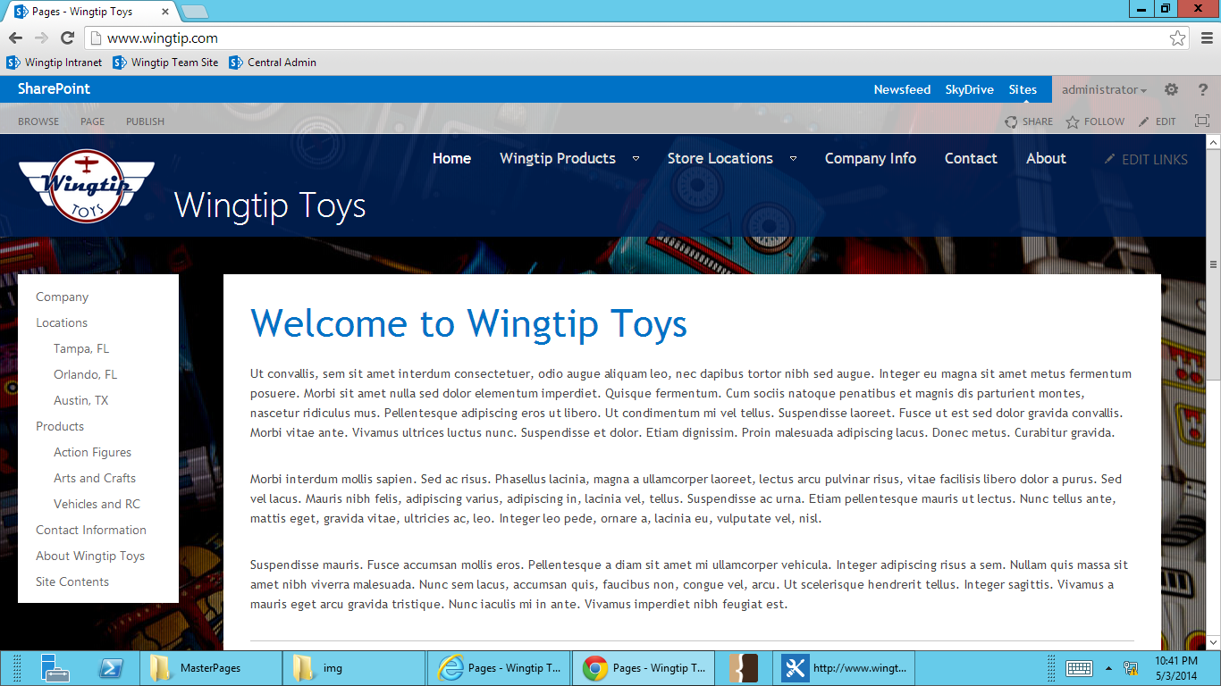

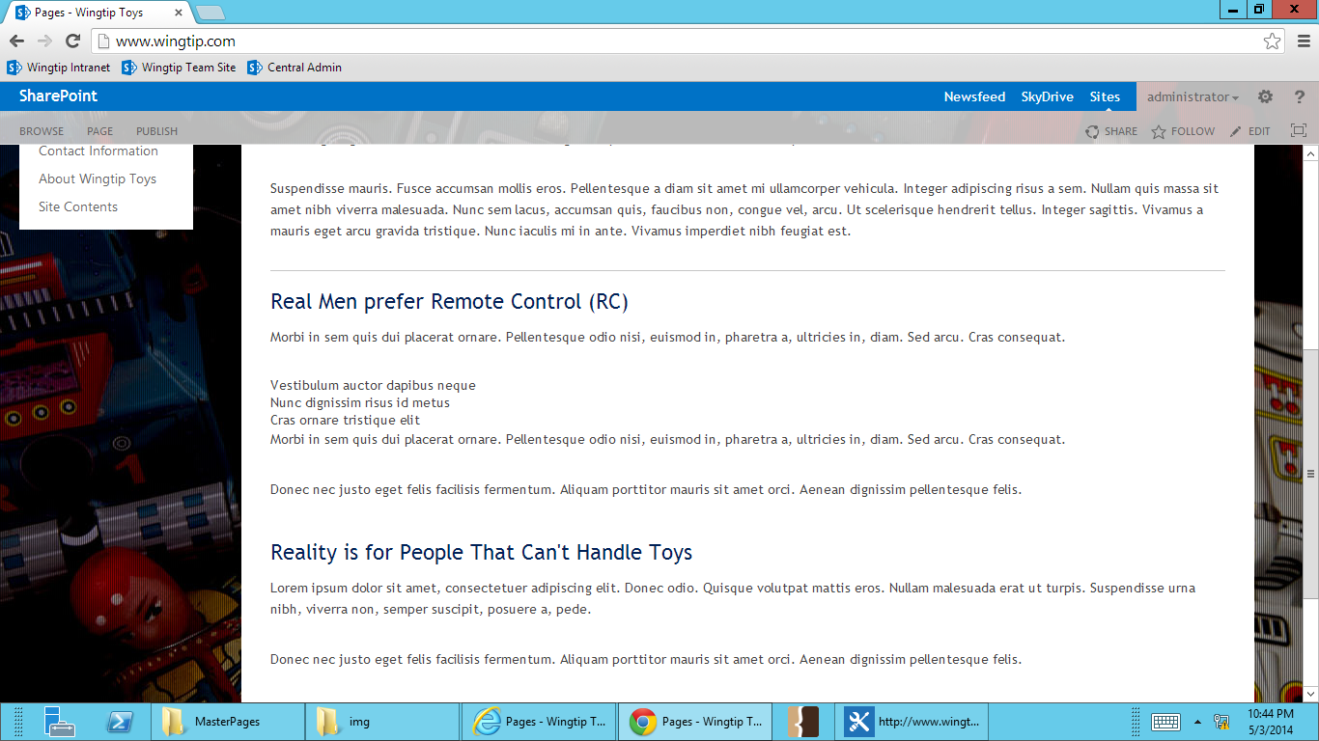

1. **Open SharePoint Designer, and select Wingtip Toys.**

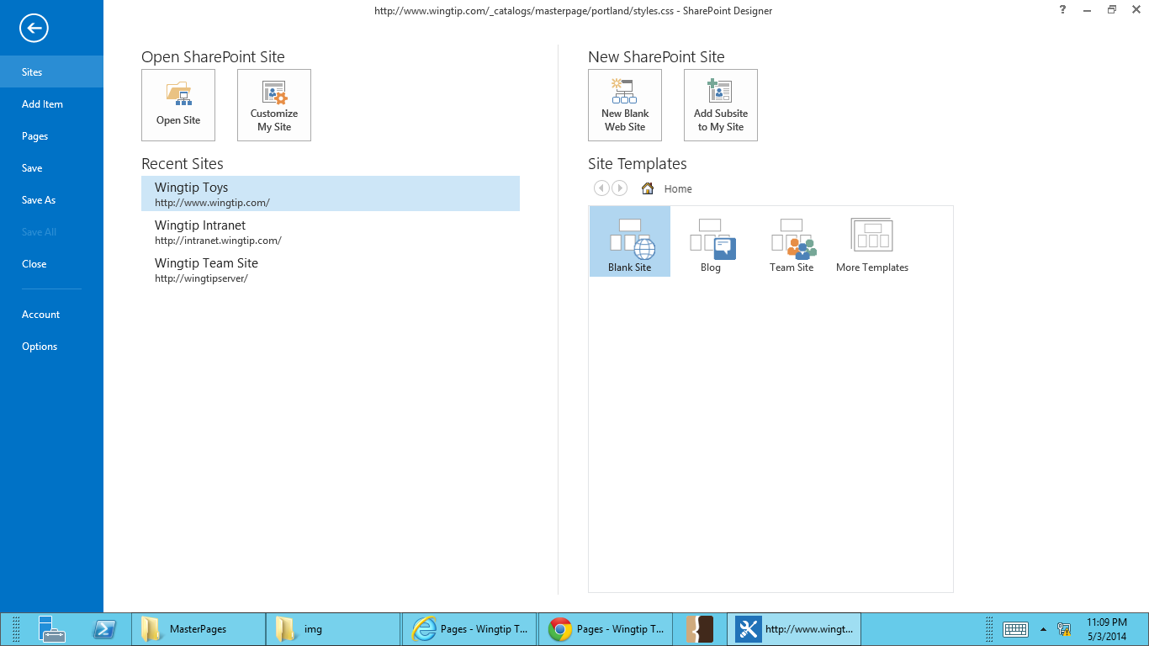

1. **Open styles.css by going to All Files -> _catalogs -> masterpage -> portland.**
2. **In styles.css, find the section for Content Layout Styles section, line 210 (remember – keep your CSS organized!).**
3. **Below .ms-siteSettings-root, add the styles listed below.**

#panel_left{

width: 48%;

padding-right: 2%;

float: left;

}

#panel_right{

width: 48%;

padding-left: 2%;

float: right;

}

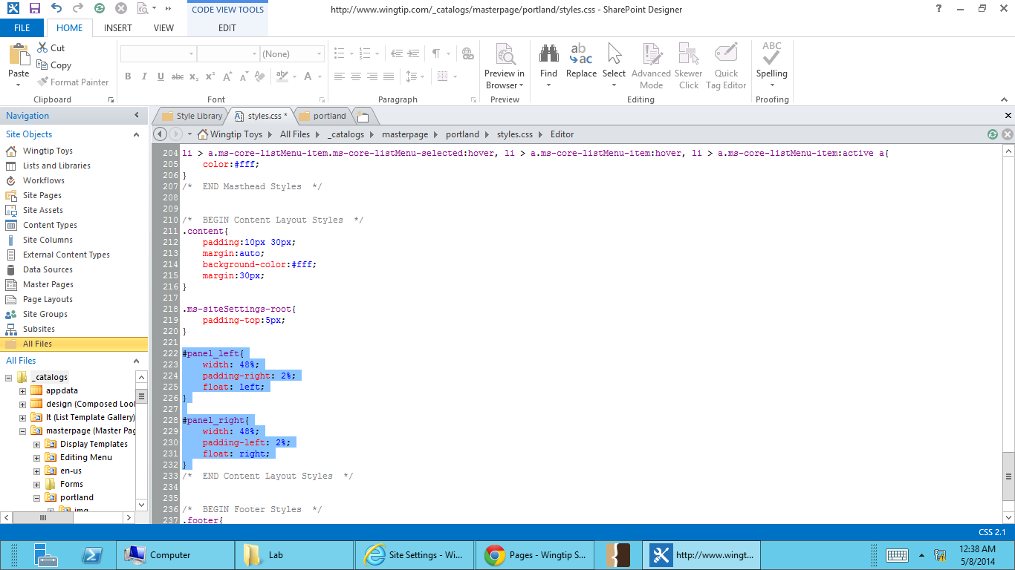

1. **Save your changes.**
2. **Go back to** <http://www.wingtip.com> **and refresh the page. You’ll see the content at the bottom of the page displaying in 2 columns.**

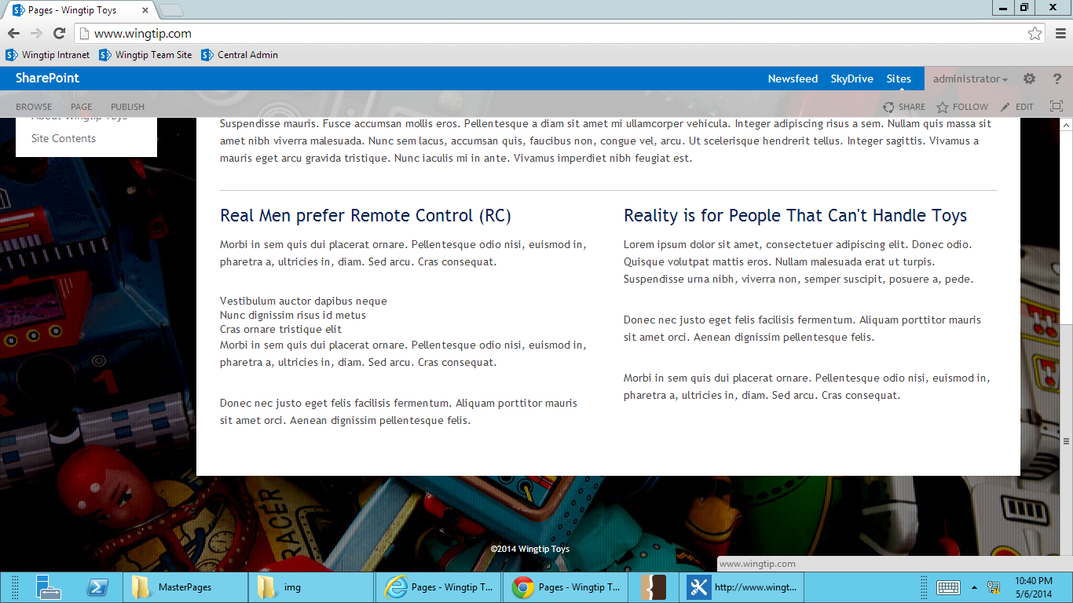

### Exercise 2: Use Developer Tools to Find and Overwrite corev15.css Styles

In this exercise you will use developer tools to target and overwrite corev15.css styles. We’ll do this exercise in IE, but the process is the same for Firefox and Chrome.

You’ll find that most SharePoint styles are for nested elements. Because of this, many of the styles from corev15.css will overwrite your custom CSS.

1. **Open** [http://www.wingtip.com/](http://www.wingtip.com/Pages/about.aspx) **in your web browser.** You’ll see that the page title, “Welcome to Wingtip Toys,” is light blue, even though our CSS has the color of h1 set to be the dark blue used in the Wingtip color palette. We need to find the corev15.css style that is overwriting styles.css



1. Hit F12 to bring up the web developer tools.
2. On the left side of the web developer toolbar, find the **white arrow** and **select it** to engage Select Element mode.

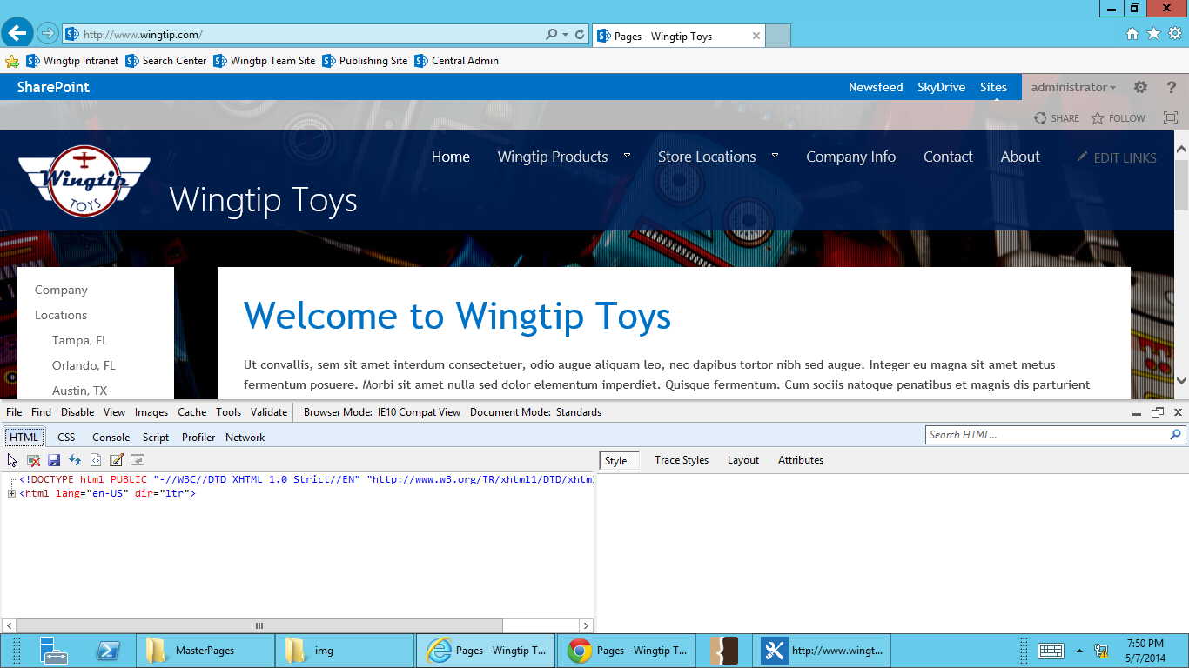

1. Hover over “Welcome to Wingtip Toys” and **click to select it**. On the right side of the web developer tool pane, scroll all the way down to see the styles applied.

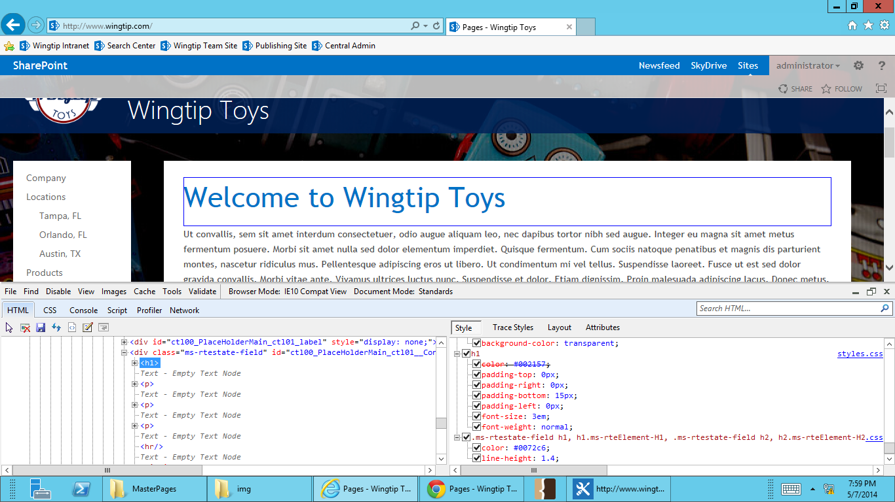

You’ll see that the h1 color style in styles.css is being overwritten by corev15.css. This is due to the style in corev15 having more targeted information about the h1 that is being displayed on the page. SharePoint constantly wraps fields and elements in divs with multiple IDs and classes. Because of this, many of the styles in corev15.css are very specific.

1. **Open SharePoint Designer, and select Wingtip Toys.**



1. **Open styles.css by going to All Files -> _catalogs -> masterpage -> portland.**
2. **In styles.css, find the section for Text Styles section, line 75 (remember – keep your CSS organized!).**
3. The div that contains this h1 uses class=”ms-rtestate-field” so the class that needs to be overwritten is .ms-rtestate-field h1. Add .ms-rtestate-field h1 to your h1 style on line 76.

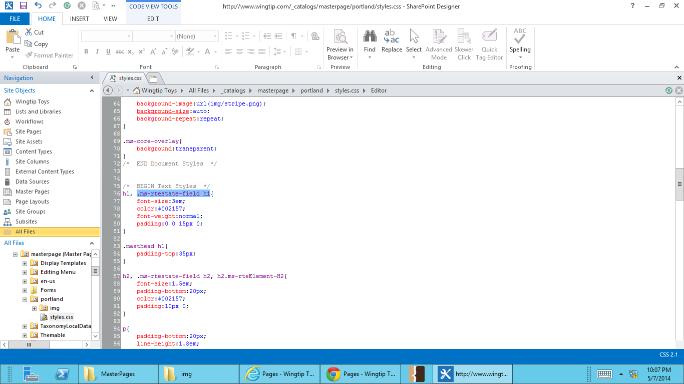

1. **Save your changes.**
2. **Go back to** <http://www.wingtip.com> **and refresh the page. You’ll see the page title is now displaying in the Wingtip blue.**

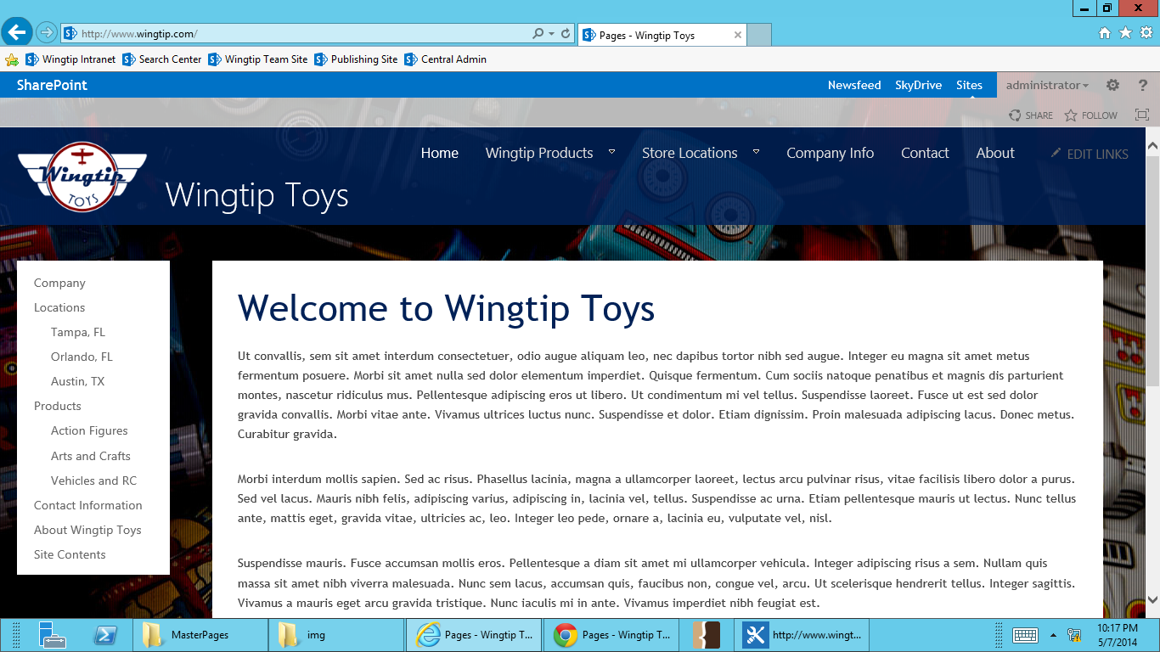

1. If you hit F12 again, you can see that the class and style you added are now overwriting covev15.css.  
     
   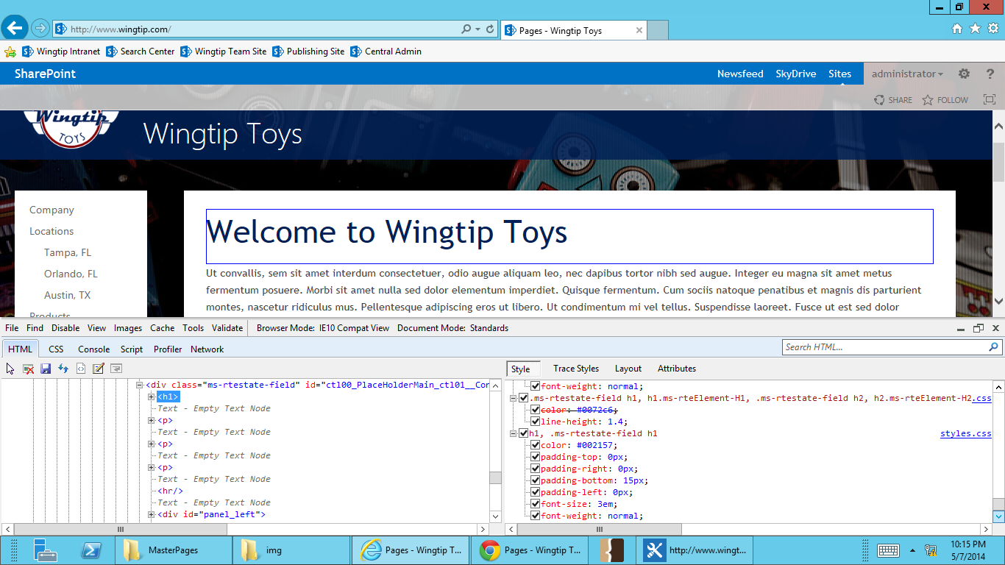

### Exercise 3: Add Web Font with @font-face

In this exercise you will add a custom font from our brand as a web font in the CSS for the page title.

1. **Open** [http://www.wingtip.com/](http://www.wingtip.com/Pages/about.aspx) **your browser. The page title is currently using the default font. We’re going to change that font to our custom font, Bonnie, using @font-face.**



1. **Open SharePoint Designer, and select Wingtip Toys.**



1. **Open portland folder by going to All Files -> _catalogs -> masterpage -> portland.**
2. **Open the extra student files folder. Find the fonts folder, and drag and drop it into the portland folder.**

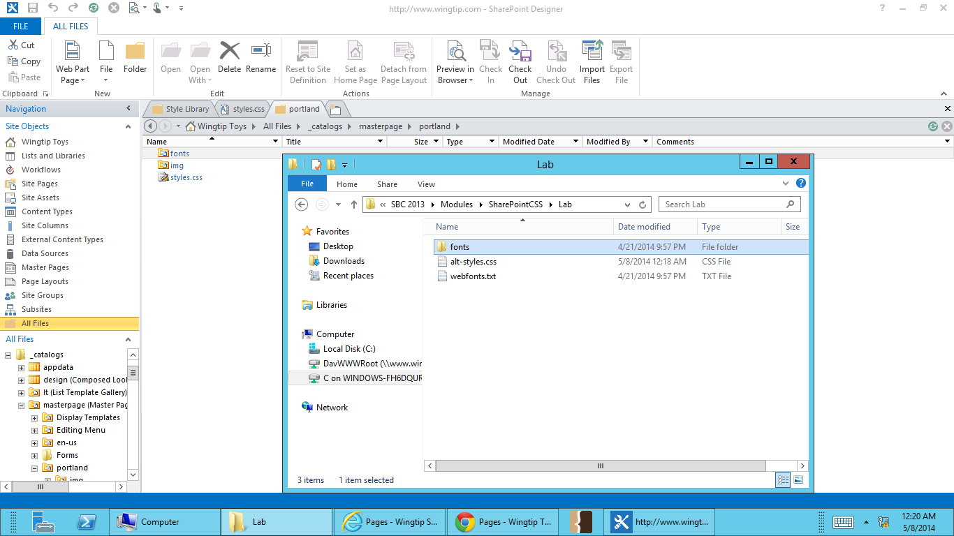

**The font folder contains 4 different font types:**

**.eot: Embedded OpenType Font, supported by IE 8 - 11**

**.ttf: TrueType Font, supported by Firefox 25 - 26, Chrome 31 - 32, Safari 7, Opera 18, iOS Safari 4.2 - 7, Android 2.2 - 4.4**

**.woff: Web Open Font Format, supported by IE 9 - 11 Firefox 25 - 26, Chrome 31 - 32, Safari 7, Opera 18, iOS Safari 5 - 7, Android 4.4**

**.svg: Chrome 31 - 32, Safari 7, Opera 18, iOS Safari 3.2 – 7**

1. **To use these fonts, they must first be declared in the CSS with @font-face. Open styles.css, and find the section for Text Styles section, line 75 (remember – keep your CSS organized!).**
2. **Add the @font-face declaration below the Text Styles comment.**

****/* BEGIN Web Fonts */****

****@font-face {****

****font-family: 'Bonnie';****

****src: url('fonts/arbonnie-webfont.eot');****

****src: url('fonts/arbonnie-webfont.eot?#iefix') format('embedded-opentype'),****

****url('fonts/arbonnie-webfont.woff') format('woff'),****

****url('fonts/arbonnie-webfont.ttf') format('truetype'),****

****url('fonts/arbonnie-webfont.svg#ar_bonnieregular') format('svg');****

****font-weight: normal;****

****font-style: normal;****

****}****

****/* END Web Fonts */****

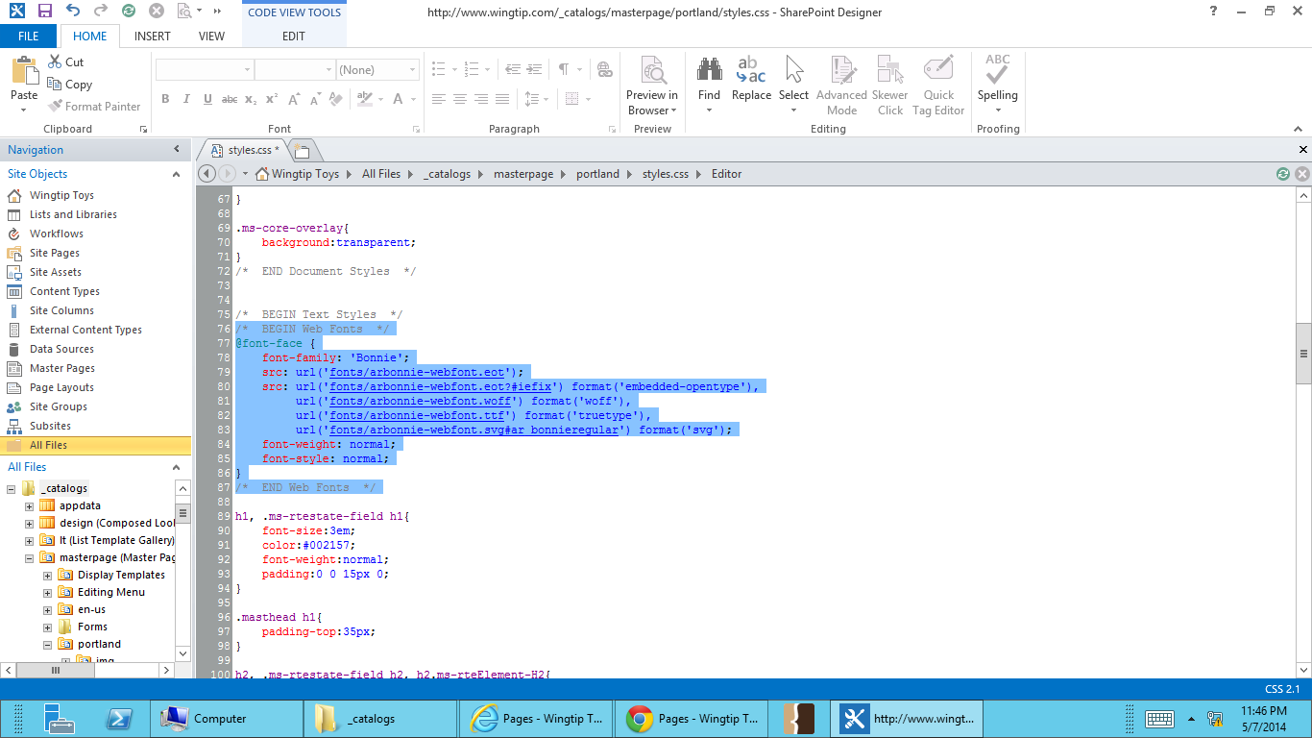

1. **Now that the web font is declared and named, it can be applied to the h1. The font-family has been named ‘Bonnie’. Add this font family call to the h1 styles.**

**font-family:'Bonnie', 'Trebuchet MS', Helvetica, Arial, sans-serif;**

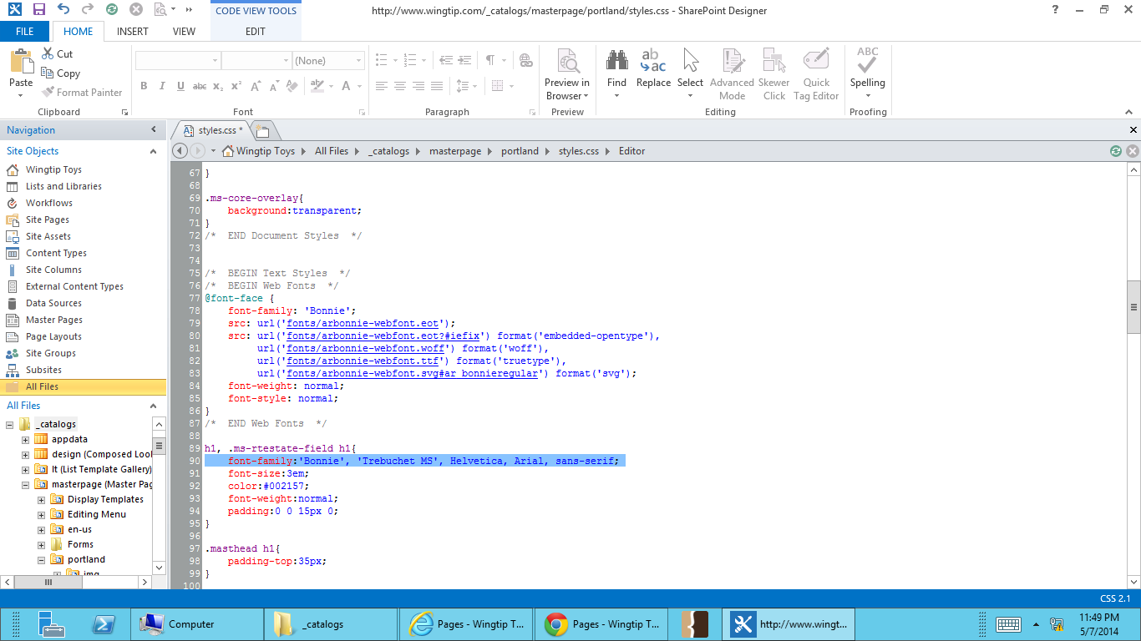

1. **Refresh the page** <http://www.wingtip.com/>. **You should now see the web font used in your page title.**

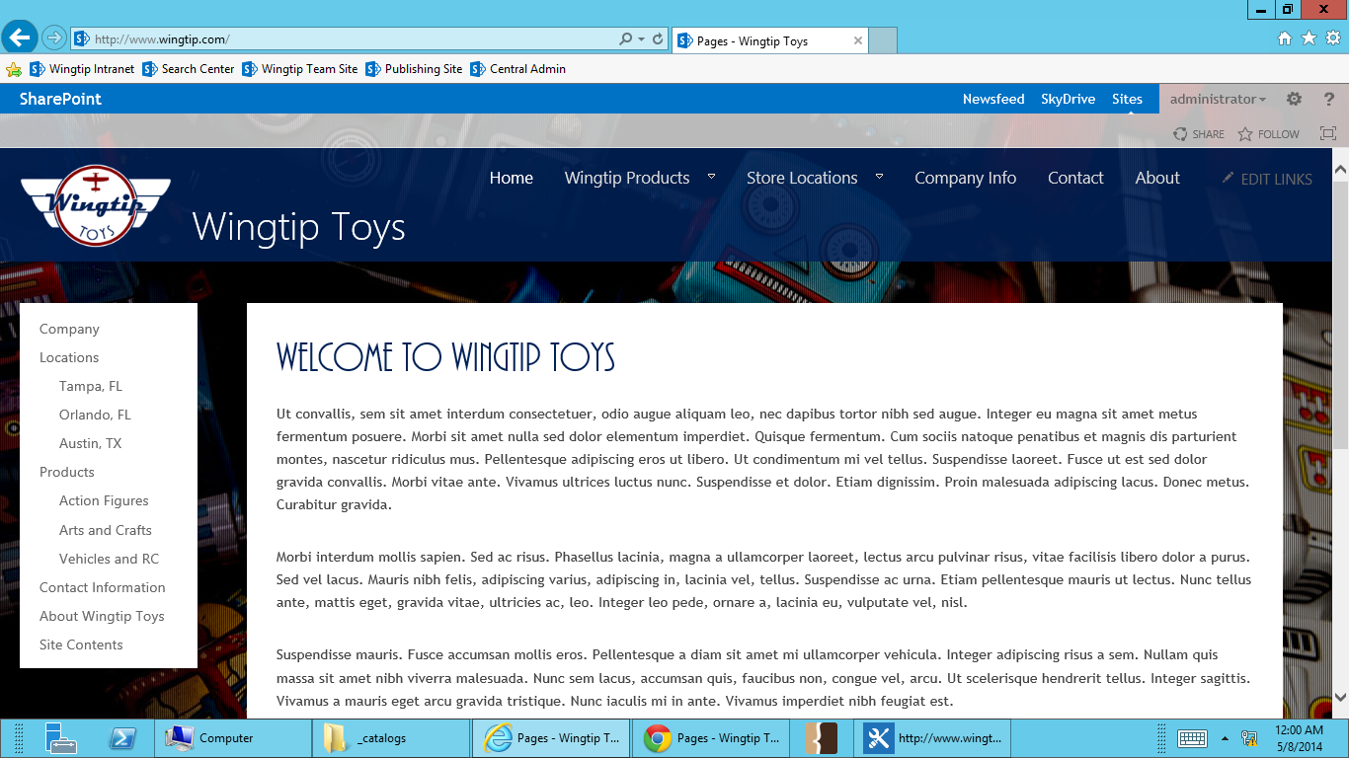

**A Note About Web Fonts**

**To use a font online, the font either must be royalty free, or you must have a license to use the font online. Purchasing a font for desktop use does not supply rights to display the font on you site.**

**Creating the different font types can be done through online font converters. The majority of online converters take fonts 1MB and smaller. This generally isn’t a problem unless it’s Asian font, which tend to be quite large. Font converters assume that you have appropriate licensing for your font. When converting your font to a web font type and using it online, you assume *all responsibility*. Font converters do not check licensing.**

### Exercise 4: Adding an Alternate CSS

In this exercise you will add an alternate CSS to you site through the SharePoint master page settings. This is helpful when you need different styles added to a subsite, but do not require any master page changes.

1. **Open**  [http://www.wingtip.com/locations/](%20http://www.wingtip.com/locations/) **your browser. You will see that, like all the other pages in the site, the main content area is has a plain white background. Using an alternate CSS, you will add a red border to the content main content background in the Locations subsite.**

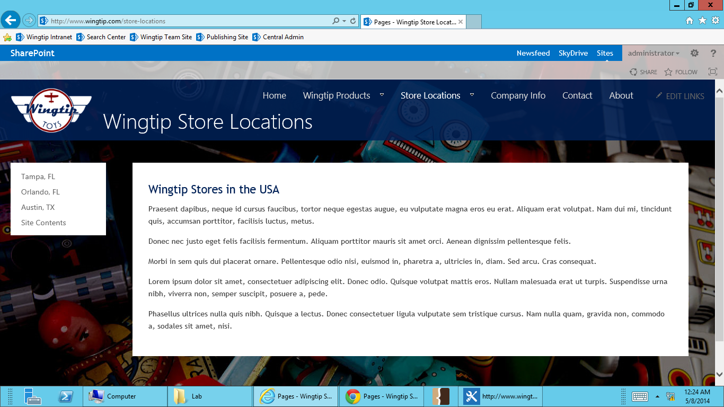

1. **Open SharePoint Designer, and select Wingtip Toys.**



1. **Open portland folder by going to All Files -> _catalogs -> masterpage -> portland.**
2. **Open the extra student files folder. Find the alt-styles.css, and drag and drop it into the portland folder.**

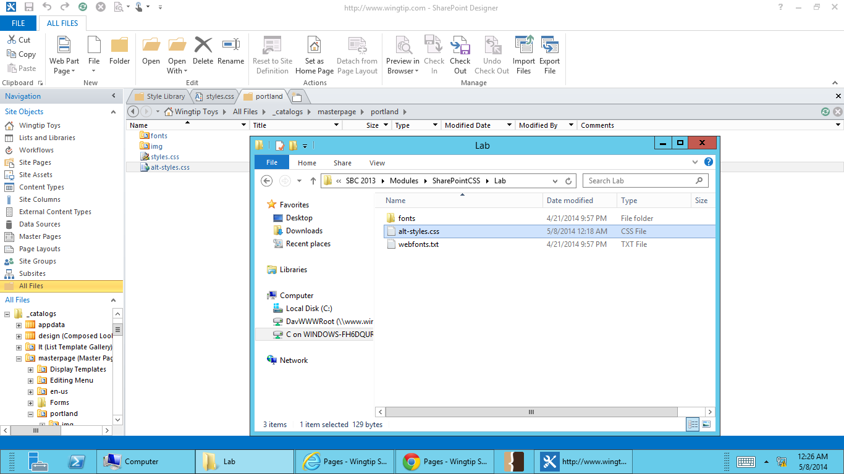

1. **In your web browser, go to Site Settings menu and select Site Settings.**

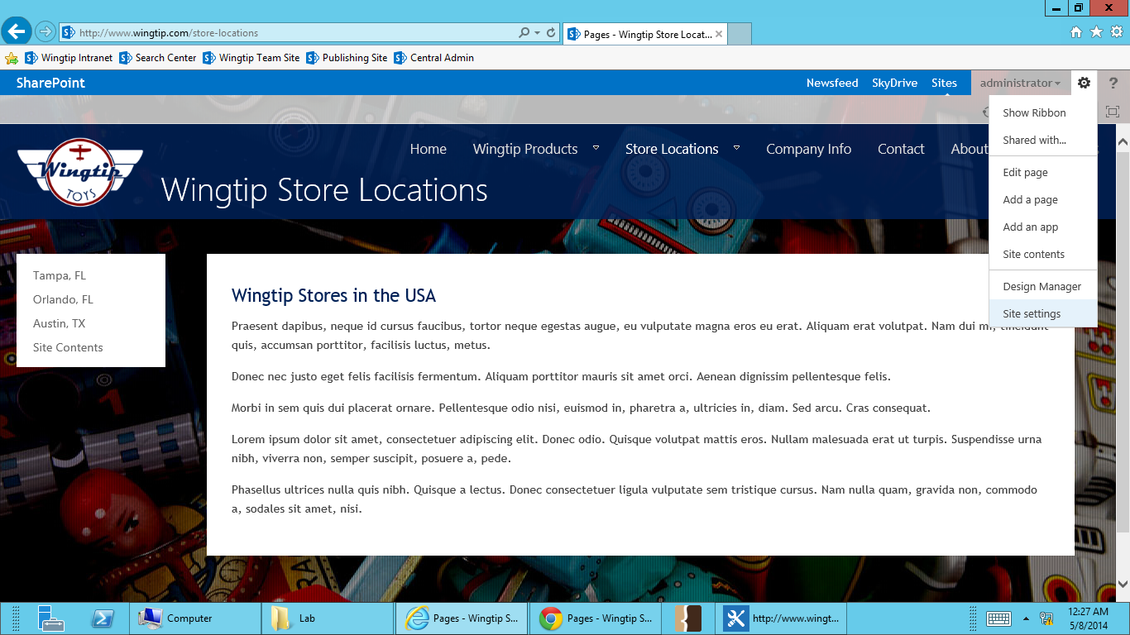

1. **On the Site Settings page, select Master Page under Look and Feel.**

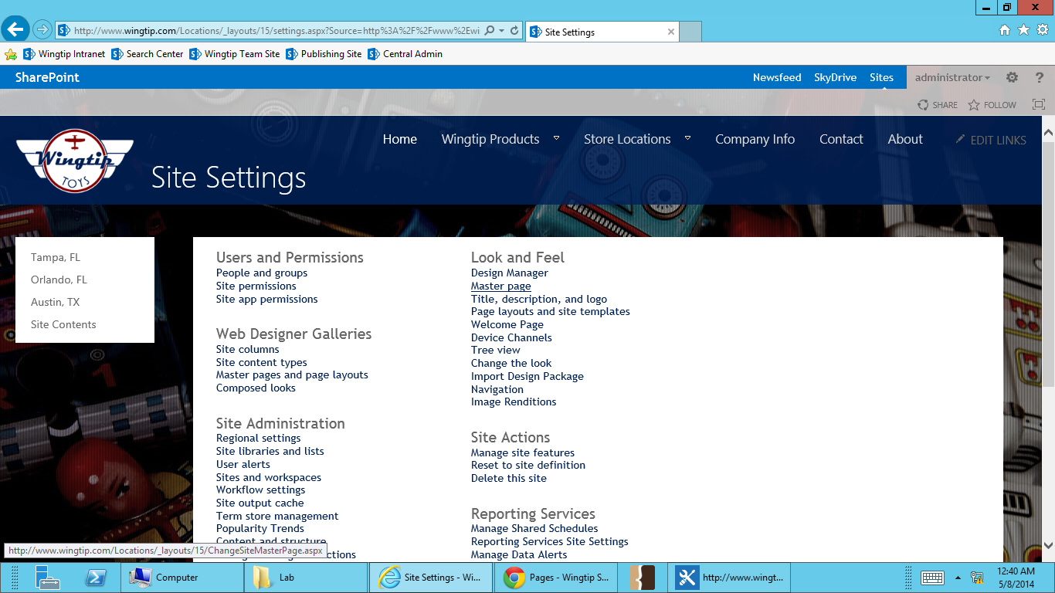

1. **Scroll to the bottom of the page, and click Alternate CSS URL to expand the alternate CSS options. Select the last radio button, which says, “Specify a CSS file to be used by this site and all sites that inherit from it:” This will allow you to enter a path for your css. Paste the path to alt-styles.css in the box next to Browse. Click OK.**

****_catalogs/masterpage/portland/alt-styles.css****

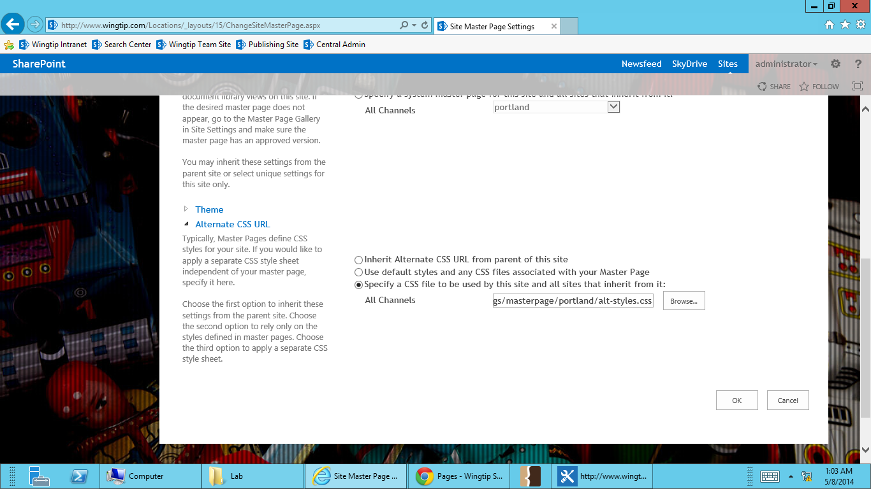

**You do have the option to browse to a CSS, but the folders that display in the navigation pane are restricted. _catalogs is not available in the folder tree, but you can browse the masterpage folder by typing in /_catalogs/masterpage into the Location (URL) field. The masterpage folder contents will then display in the main pane, allowing you browse through the folder.**

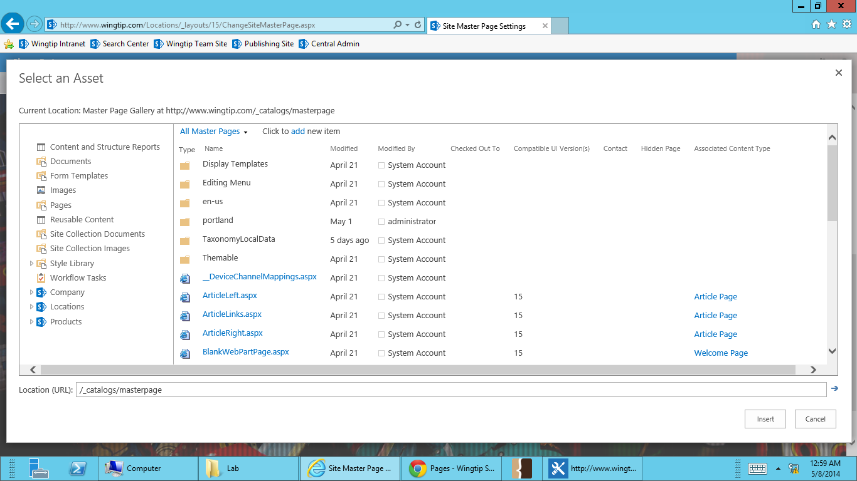

1. **You will see that any pages in the /locations subsite now have the red border around the content box.**

